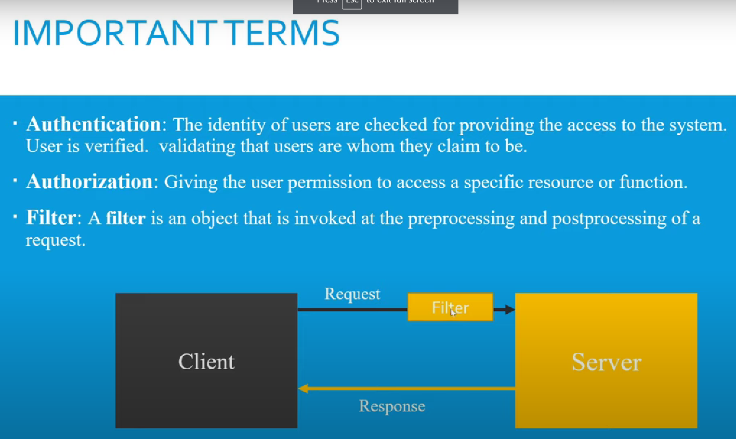

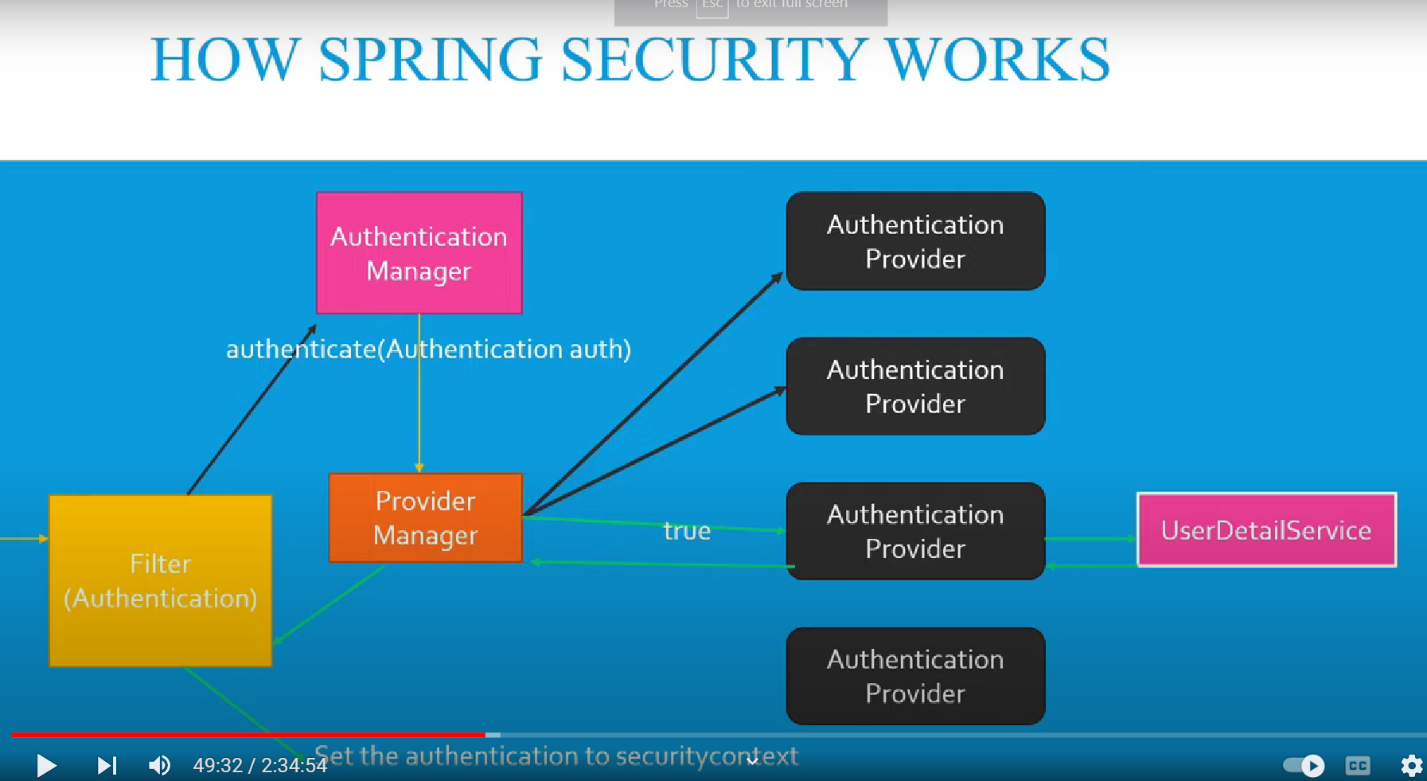

***Filter*** is the main entry point for the spring security. It intercepts each requests. Filter doesn’t have any authentication power. It just intercepts the requests and creates authentication object and keeps basic information within it. And it will delegate the request to ***AuthenticationManager***.

Authentication of the user/client is the responsibility of ***AuthenticationManager***. It calls a method ***authenticate(Authentication auth)*** . AuthenticationManager is an Interface so, it depends on some implementation to help it authenticate.

***Authentication Providers***, are the actual authentication implementations based on type of authentication required. Authentication Manager calls UserDetailService and loads the user details. Then Authentication Providers can call ***authenticate(Authentication auth)*** method in Authentication Manager and sets an object of Authentication with a property with Authentication=true. Then it returns valid authentication Authentication object to Provider Manager. Then finally Provider Manger will send the valid Authentication object to the Filter. Finally the Filter will set the object in SecurityContext. When the Authentication object is set in SecurityContext then the request can move forward.

***Provider Manager*** – Authentication Manager cannot determine which Authentication Provider to call for authentication. So, it takes help of Provider Manager.

***UserDetailService*** – Authentication Providers take help of UserDetailService to pull user data/information from database using a method called ***getUserByUserName***().

